RG_Grocery - Project Showcase

## 🔐 User Login Page

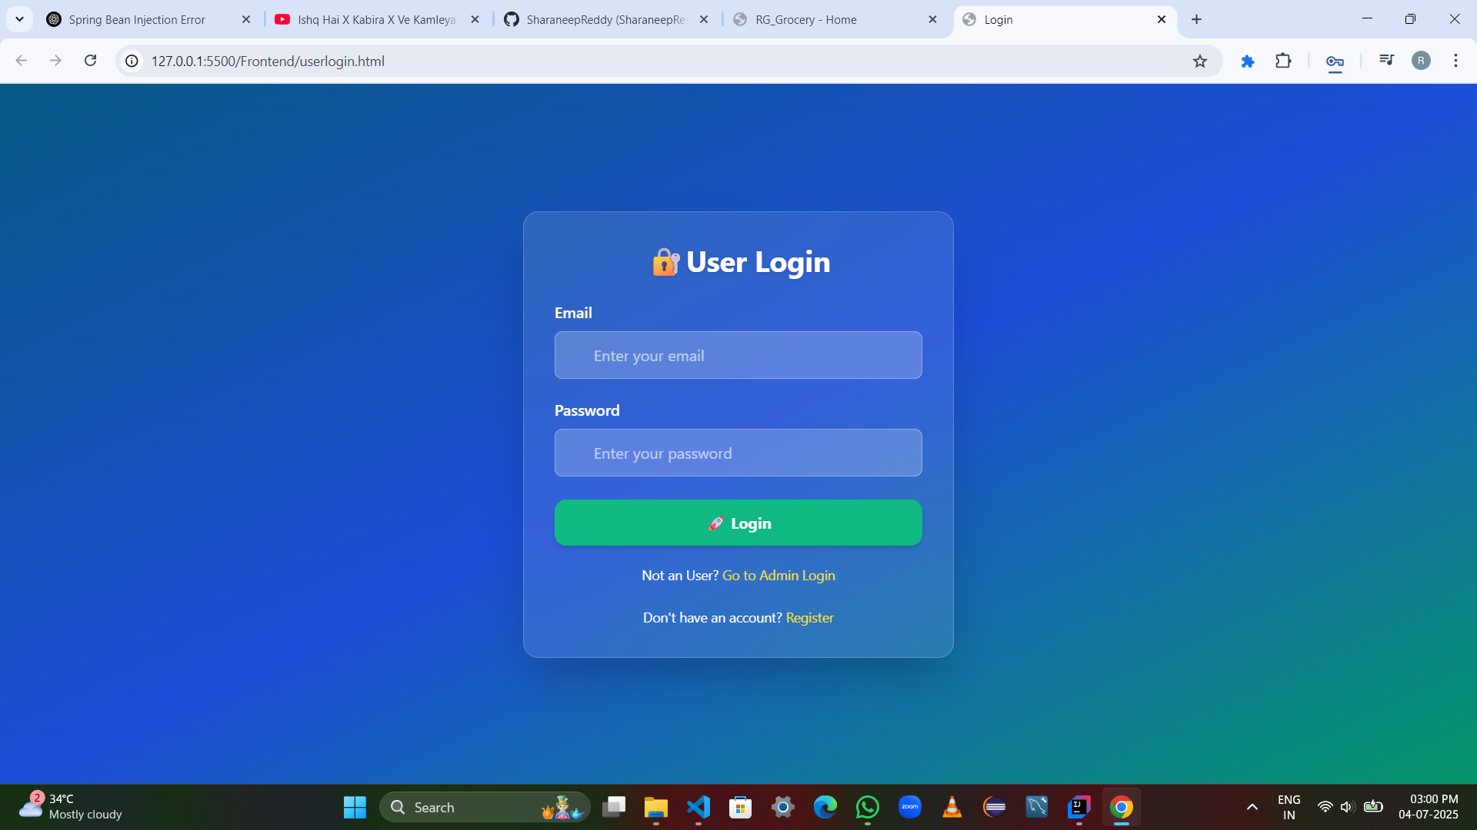

## 👤 Admin Login Page

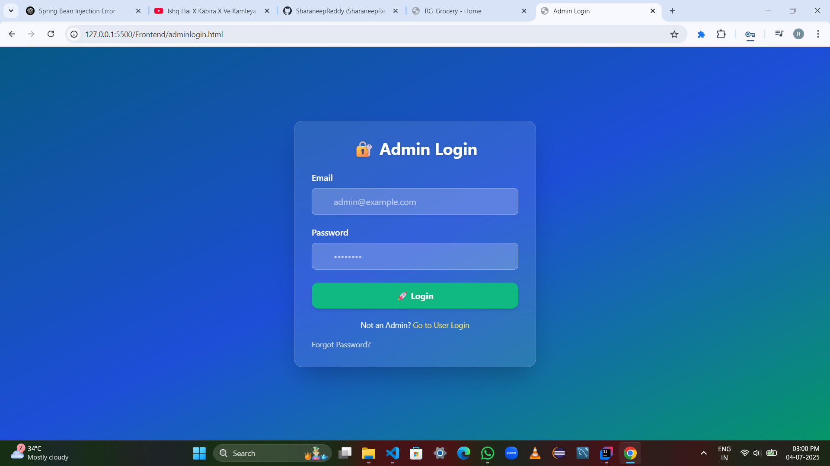

## 📝 New User Registration

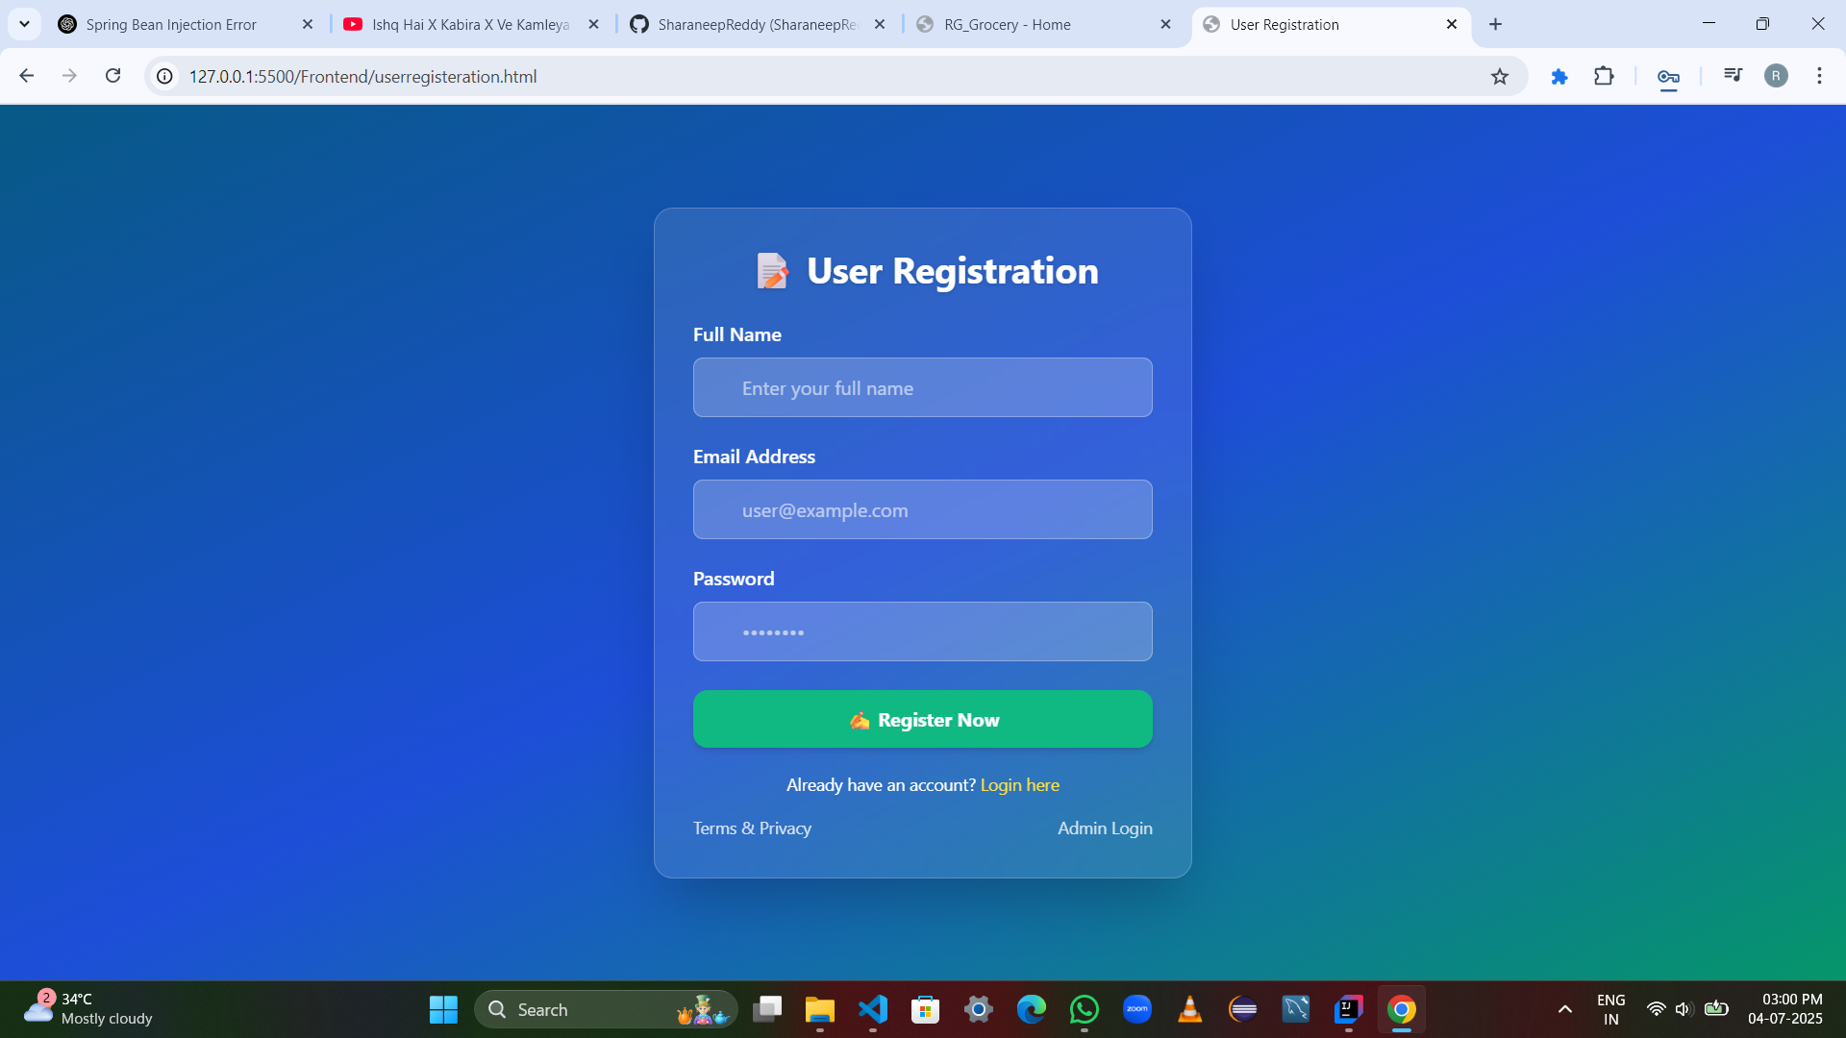

## 🏠 Grocery Home Page

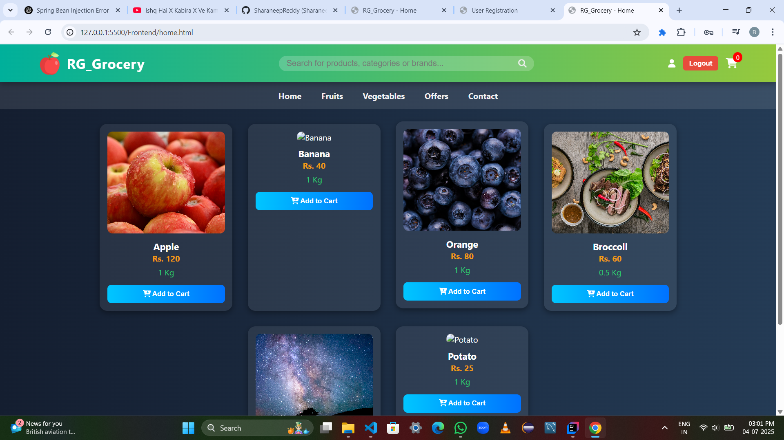

## 🛒 Cart Page

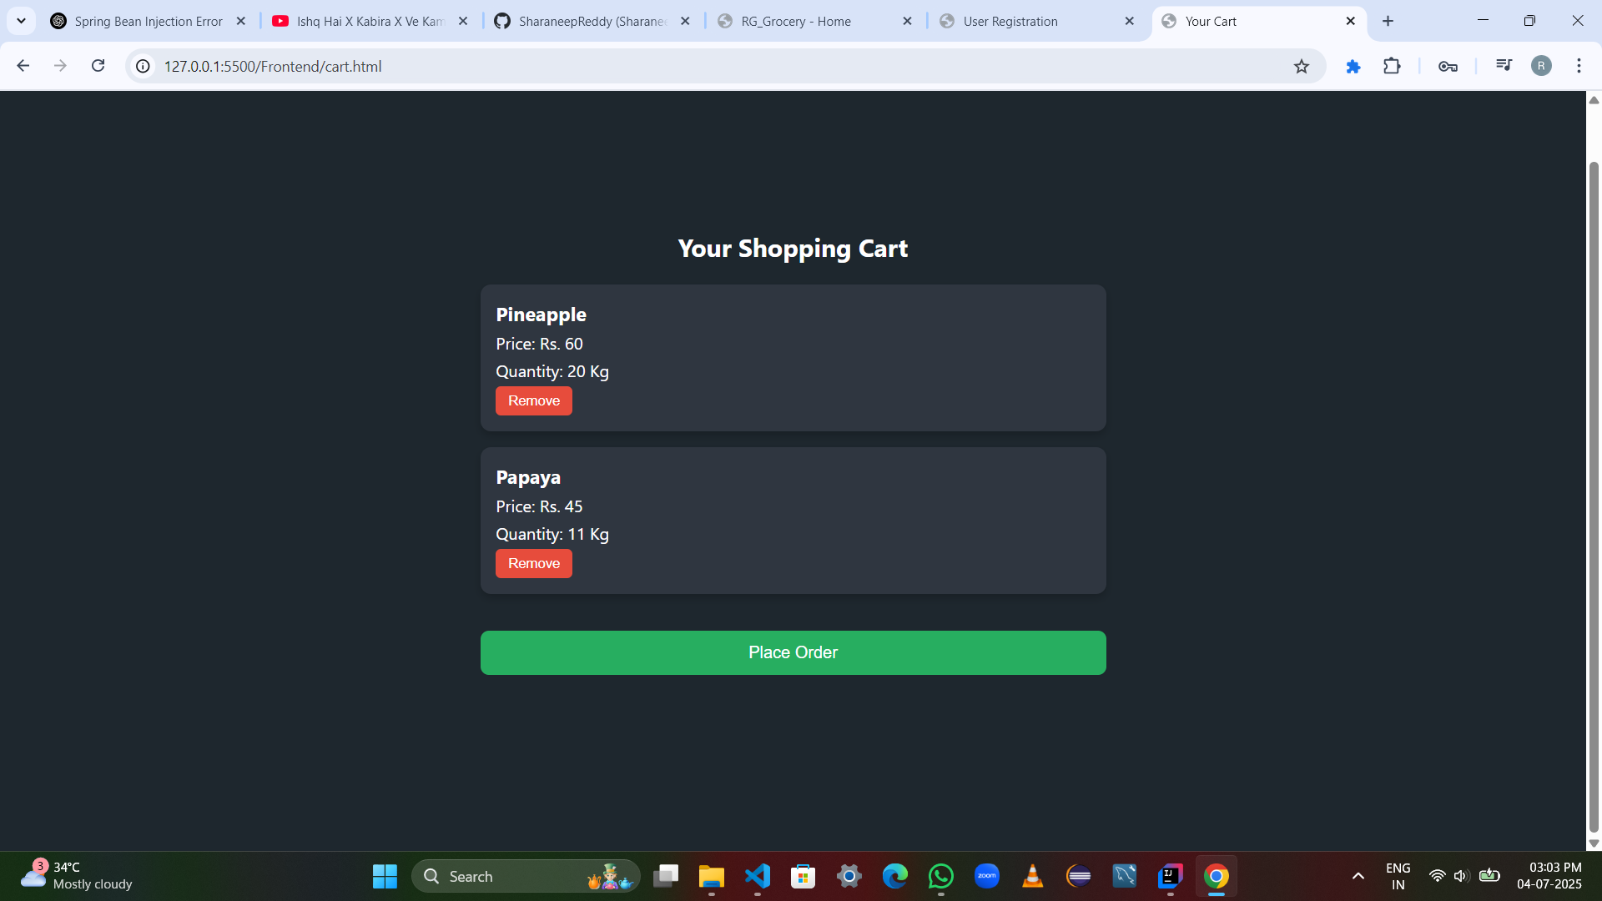

## ✅ Order Successful Page

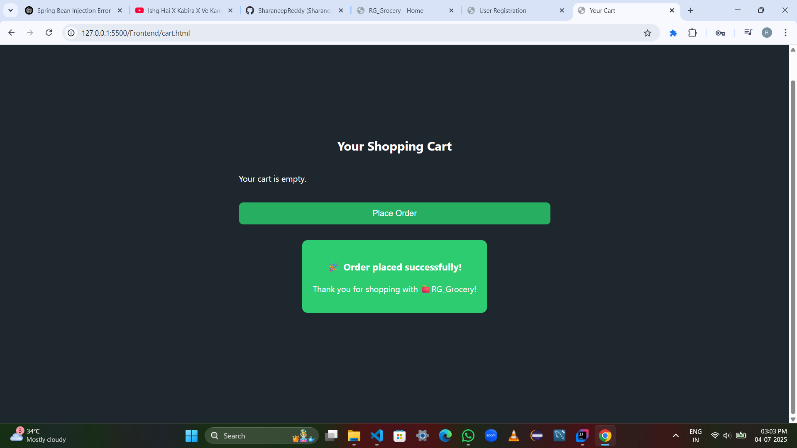

## 🧑‍💼 Admin Panel -

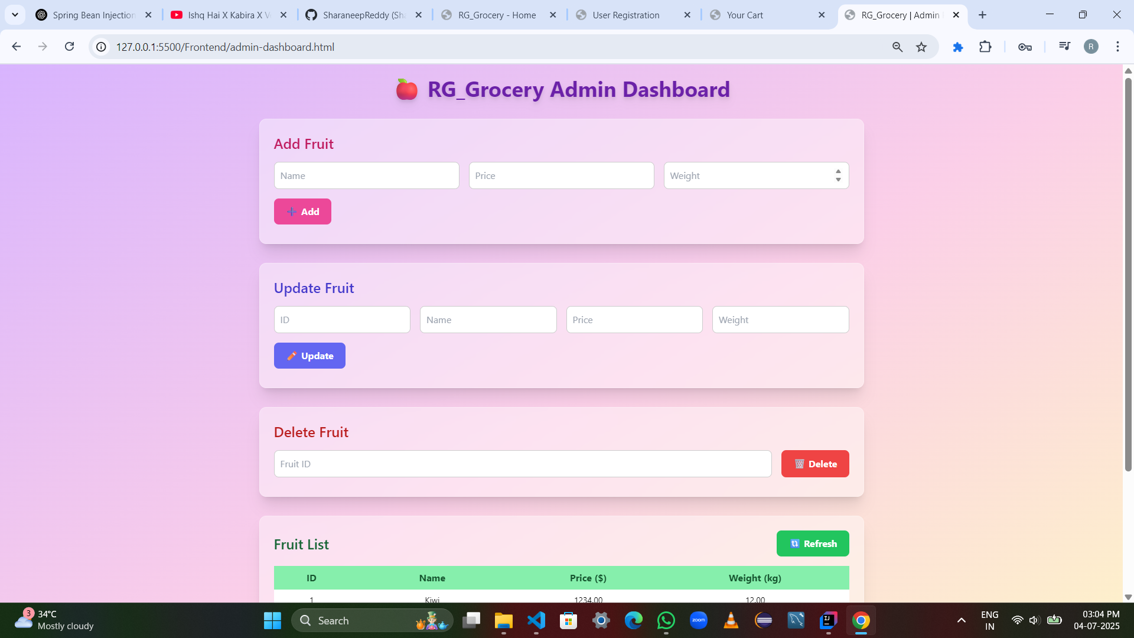

## 🗑️ Admin Panel - Add Products

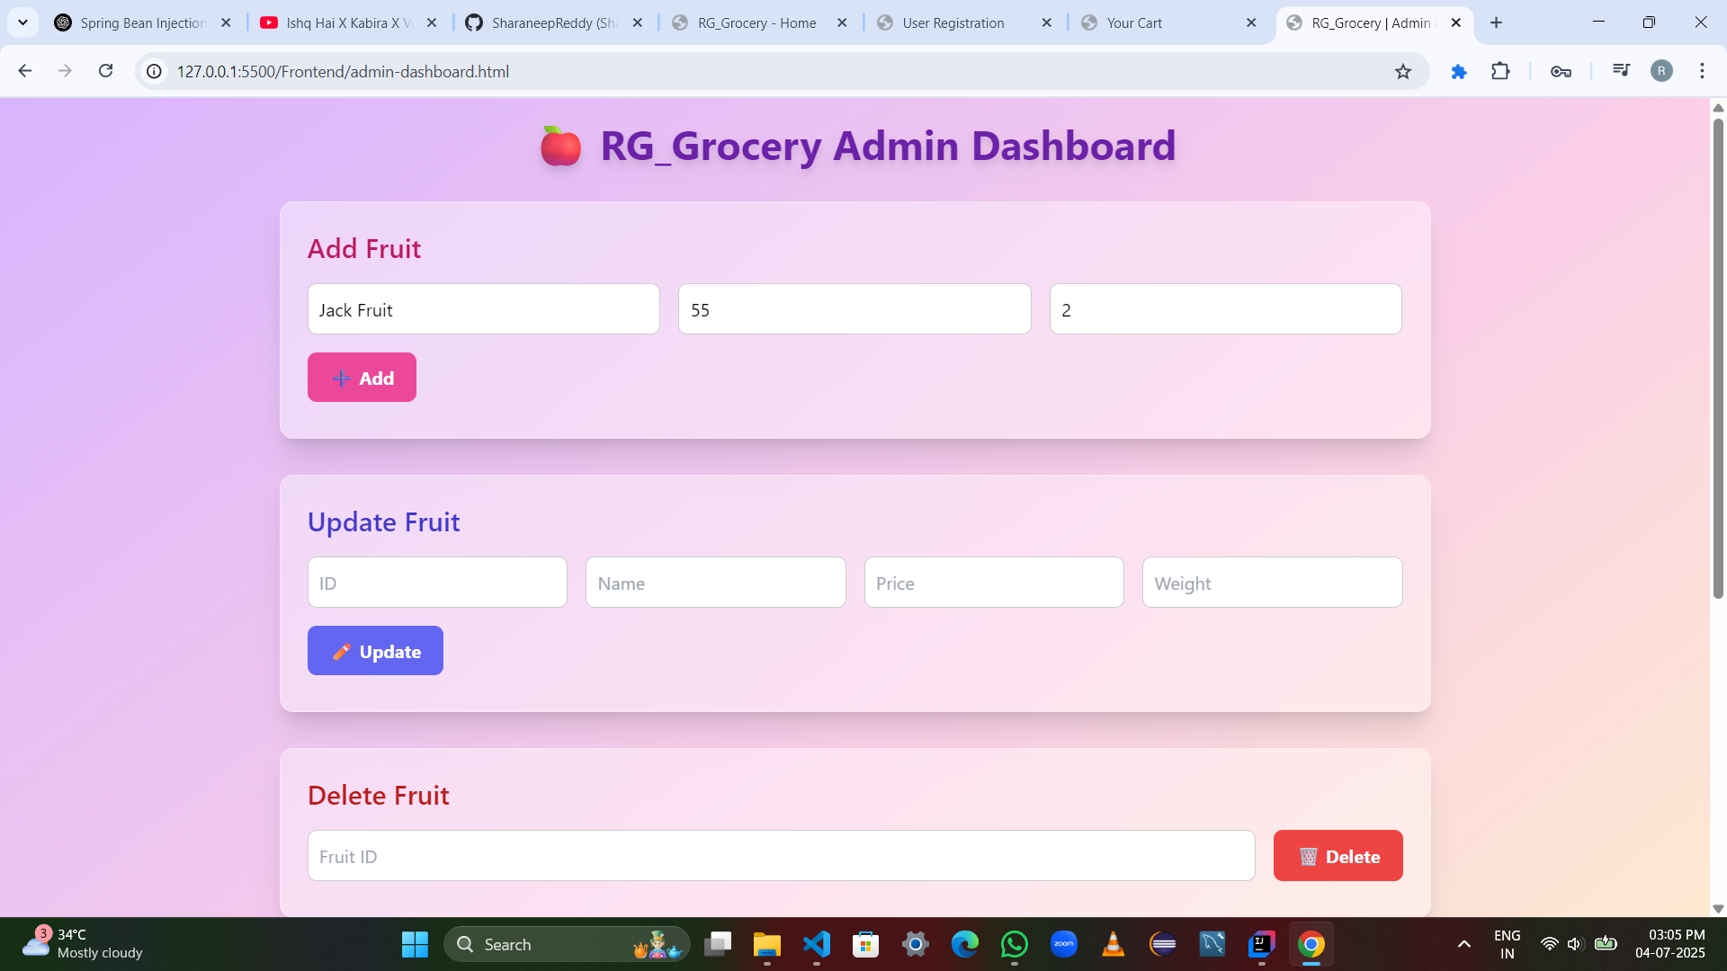

## ✏️ Admin Panel - All Products in Store

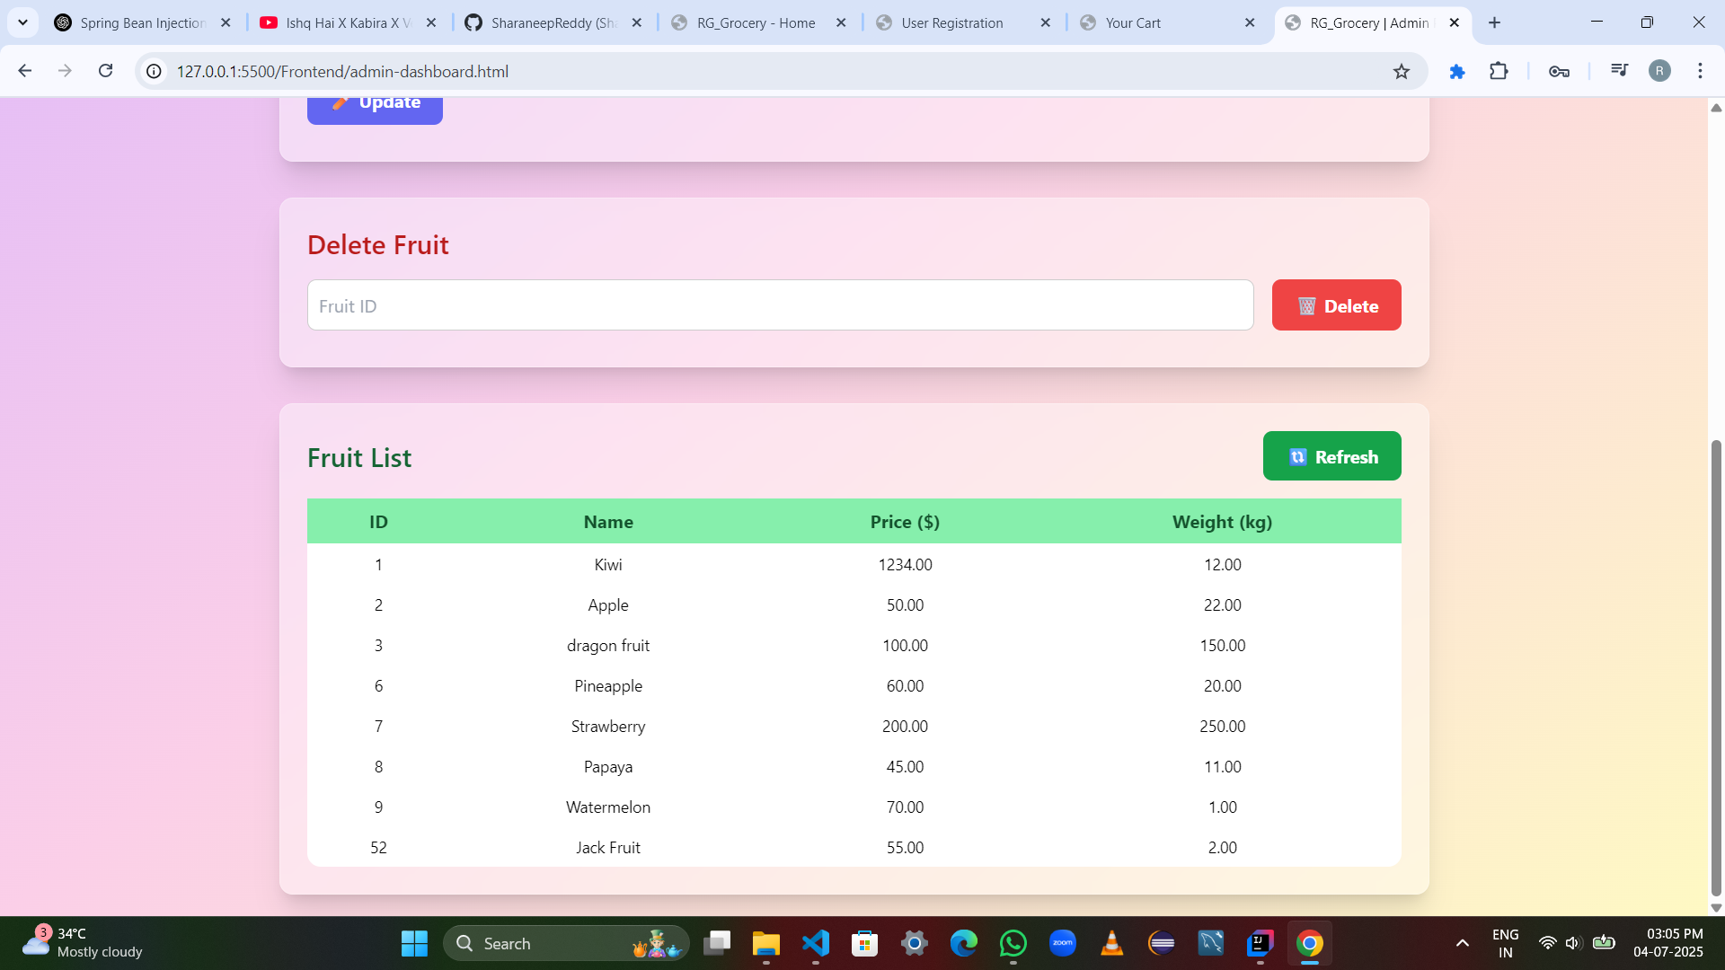

## 🏬 Admin Panel - Delete Products

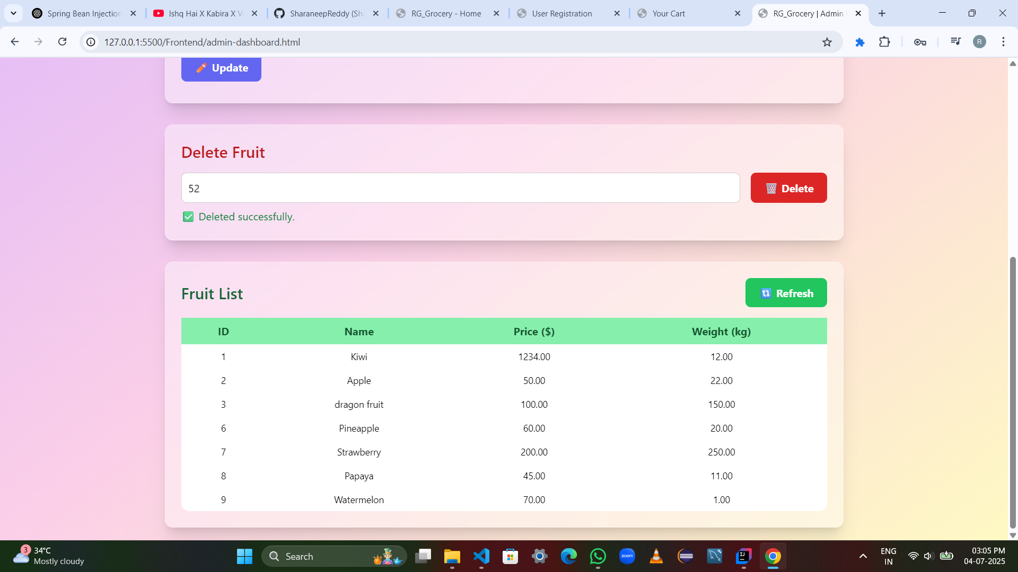

## 🏬 Admin Panel - Update Products

